How to Update Firmware of Motor Controller

- Only motor controller with firmware version 2.00 and above can be update. The firmware version of you motor controller can be found on SynScan hand control by entering menu “Utility\Show Information\Version” and pressing the scroll-up button one time.
- Download “MC Firmware Loader.zip” from our web site and extract it to a folder of your PC’s hard disk, for example, C:\MCFirmwareLoader. Create a shortcut for this application on the desktop of Windows.
- Download the correct motor controller firmware for your mount from our website and store it to the same folder of the MC Firmware Loader. It is a file with “.MCF” extended name.
- Connect SynScan hand control to the mount. Connect SynScan hand control to the PC’s RS-232C serial port with the PC-link cable that comes with the SynScan hand control.
- Turn on power to the mount, finish the initialization routine on the SynScan hand control, and skip alignment routine.
- Enter menu Utility\PC Direct Mode.
- Run the MC Firmware Loader on PC, it will open the following window.
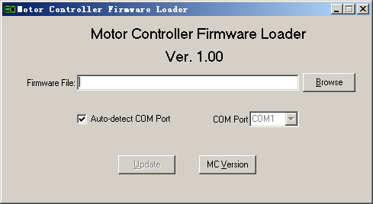
- Click the “MC Version” button, there will be a version number shown at the bottom of the window. The application might report “Can not connect to a motor controller” for the first time that you try to check the MC version, ignore it and try again.
- Use the “Browse” button to select the new firmware file. It is the file with “.MCF” extended name.
- Click the “Update” button to loader the new firmware to the motor controller. When the update routine finished successfully, Turn off the power to the mount and restart it.
- If the MC firmware reports a failure during the update routine, turn off the power to the mount and then turn on it again. The SynScan hand control might report “No link to M.C.”, user can press the “ENTER” button to skip this information and repeat the update routine. If the updating keeps failing, it might means the serial port of the PC is not good, please use another PC to update the firmware.
- A desktop PC with serial port is recommending for updating the firmware.

